**CMPS 350 Project Phase 1 – Report**

**Education Platform**

**(10% of the course grade)**

|  |  |
| --- | --- |
| **Group Members** | Marcus Monteiro (202206892)  Josh Calma (202203604)  Mohd Bashar (202205153)  Audre Caraig (202212698)  **Emails:**  [mm2206892@student.qu.edu.qa](mailto:mm2206892@student.qu.edu.qa);  [jc2203604@student.qu.edu.qa](mailto:jc2203604@student.qu.edu.qa);  [mb2205153@student.qu.edu.qa](mailto:mb2205153@student.qu.edu.qa);  [ac2212698@student.qu.edu.qa](mailto:ac2212698@student.qu.edu.qa); |
| **GitHub link** | <https://github.com/marcus-mm2206892/student-management-website> |

**Grades :**

**The student fills only the “Implementation Percentage”: Please specify either: *Working (completed x%)*, *Not Working (completed x%)* or *Not done*.**

|  |  |  |  |  |
| --- | --- | --- | --- | --- |
| **Criteria** | **Points** | **Implementation Percentage** | **Implementation Quality** | **Your Grade** |
| Design and implement the app Web UI and navigation using HTML, CSS and JavaScript. Including designing the App Web UI and navigation. | 50 | Working (completed 100%) |  |  |
| Design and implement the Web API and data access repositories to read/write the app data JSON files. | 30 | Working (completed 100%) |  |  |
| Application modeling (e.g. UML diagrams) to explain the data entities and the functionalities | 5 | Working (completed 100%) |  |  |
| Testing documentation using screen shots illustrating the testing results. | 5 |  |  |  |
| Team work quality. Contributions of team members - All members should collaborate and contribute equally to the project. | 5 |  |  |  |
| Project report – description of the implemented app, what is implemented, what is missed .. | 5 |  |  |  |
| **Total** | 100 |  |  |  |
| **Plagiarism, outsourcing, free riders** | -100 |  |  |  |
| **Delivery behind the deadline** | -5 |  |  |  |

**Important remark: In case of copying and/or plagiarism or not being able to explain or answer questions about the implementation, you lose the whole grade.**

**\* Criteria for grading the functionality:**

- The functionality is working: you get 70% of the assigned grade.

- The functionality is not working: you lose 40% of assigned grade.

- The functionality is not implemented: you get 0.

- The remaining grade in all cases from above **is assigned to the quality of the implementation**,

- The grades are distributed on the various use cases, when the design/implementation is partial, you get only the grades of designed/implemented use cases.

Code quality criteria, include:

- Use of meaningful identifiers for variables and functions (e.g. using JavaScript naming conventions)

- Pages are responsive

- Clean code: simple and concise code, no redundancy

- Clean implementation without unnecessary files/code

- Use of comments where necessary

- Proper code formatting and indentation.

**You lose marks** for code duplication, poor/inefficient coding practices, poor naming of identifiers, unclean/untidy submission, and unnecessary complex/poor user interface design.

**Important Remark**:

**[Grades: 100-85]:** Will be given only to **fully functional application** with **all the quality criteria cited above met** and the project has excellent **design for the various functionalities**. **The report is professional**.

**[Grades: 85-80]:** Will be given only **to functional application** **with most of all the quality criteria cited above met** and the project has good design for the various functionalities. **The report is professional**.

**[Grades: 80-75]:** 80% of the application functionalities are functional. The project respects partially the quality criteria. **The report is professional** but misses some information.

The grades are not negotiable. We expect that only a small portion (around 15%) of the class will be able to meet the criteria for the grades **[100-85]. You should work hard to and demonstrate the merits of your application to earn those grades.+**

# Description of your proposed platform

Give an overview of how your application works

Our project is a comprehensive student management web application designed to streamline university academic processes. Students can log in to browse and search available courses, register for classes, and view their personalized learning paths. Instructors can submit grades for their courses, while administrators can create courses, manage class sections, and approve or reject them as needed. The system also includes a weekly schedule view to help all users stay organized and informed.

//Need to explain more, how are we fetching/writing data, implementation, etc.

# Application Design

# Use case diagram

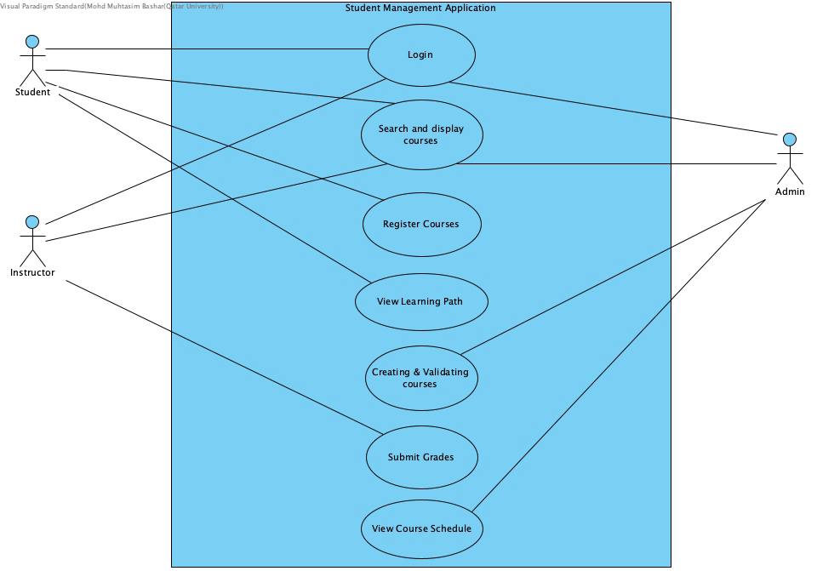

# Entities class diagram

Describe your data as a class diagram or Entity Association diagram

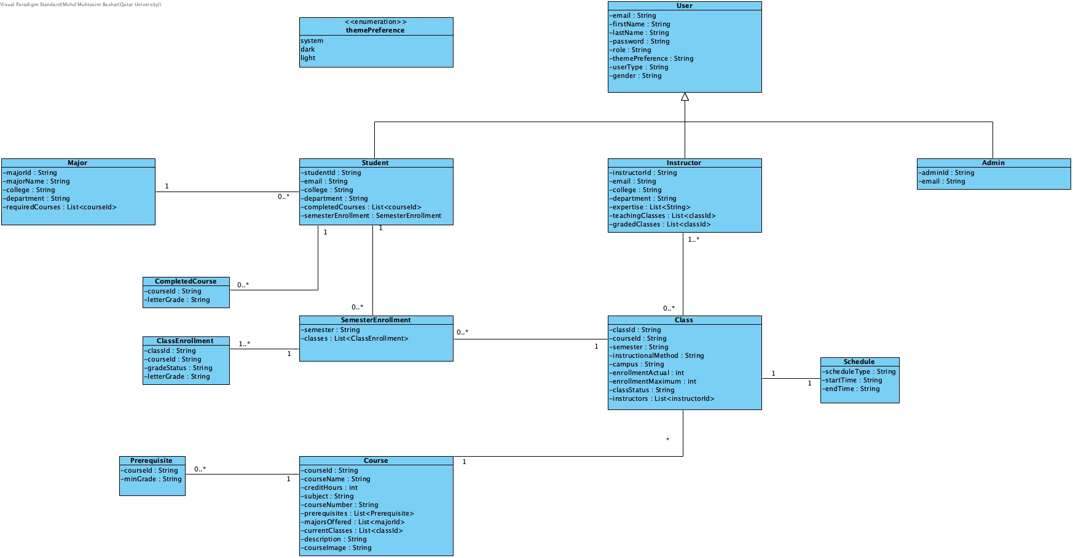

# Web API class

List all the methods (functions) to query your data entities

# Implementation

# Implemented use-cases

All use cases are implemented.

Use Case 1, Login

Use Case 2, Search and display available courses

Use Case 3, Register in a course

Use Case 4 View student learning path

Use Case 5, Creating and validating courses and classes (Admin)

Use Case 6, Grade submission (Instructor)

Use Case 8, Courses weekly schedule view (Admin)

# Unimplemented use-cases and not functioning parts

Use Case 7, Course-Instructor Assignment is optional and was not implemented.

# Testing

# Use case 1

# Use case 2

# Use case 3

# Use case 4

# Use case 5

# Discussion of the project contribution of each team member

|  |  |
| --- | --- |
| **Student name** | **Student contributions** |
|  |  |
|  |  |
|  |  |
|  |  |
|  |  |